Are We Wrong or Better?
By Diana Heathcote
It is apparent how far grooming has evolved for the past.
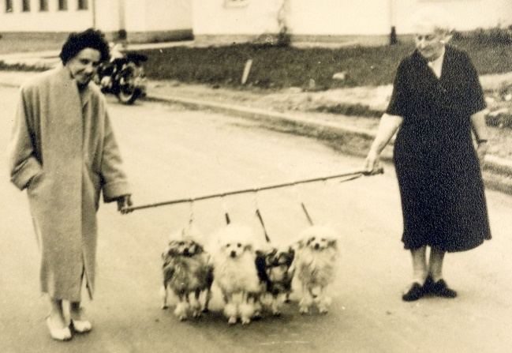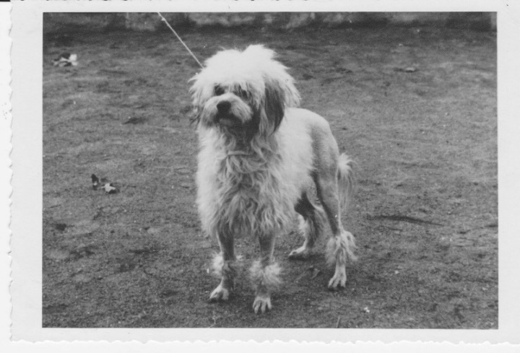
Photo credit: Madame Bennert and Gini Denninger
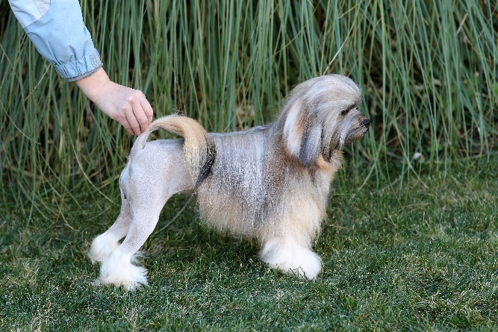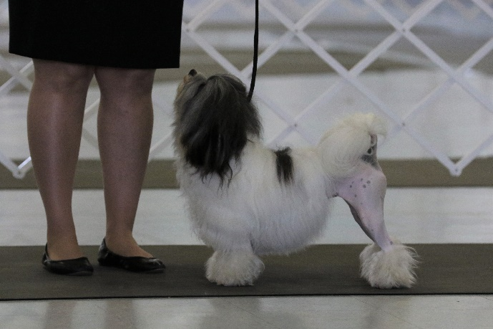
Photo credit: Sean Heathcote, Left: Gch Kiji Yield To Nothing FDC CGCA CGCU TKE Right: Ch Kiji Bed of Roses TKP CGCA CGCU
The grooming practices of today are vastly different from the grooming of our earlier Löwchen. Many of our grooming lines are derived from keeping the dogs clean and easier to maintain; some Löwchen even had shaved faces. Today, we see much more hair and consistency in the grooming lines. Grooming practices have also changed with better products to preserve fuller and longer coats. Also, lifestyles of different owners allows for easier maintenance and retention of coat.
This brings up the following questions; How much is too much? According to the standard it states: “The unclipped areas must be completely natural and untrimmed. On no account should the unclipped areas be smoothed, shortened, shaped or otherwise tidied with anything other than a comb or brush. Any clip other than specified or any shaping or scissoring of the long coat are disqualifications.”
Completely natural can be interpreted in several different ways. 1. The dog plays and lives as all pet dogs do with grooming as needed. 2. The dog doesn’t play with other dogs and lives in a way where the coat cannot be broken. 3. The dog lives a pet dog life but also has a strict grooming schedule to keep hair maintained but allows the hair to break off naturally.
The products and tools available make just about any outcome to the coat without it being overly complicated. By using these products and tools to obtain the desired look does this mean the coat is no longer “natural” or does it mean we have enhanced what genetics have given us?
Have we missed the mark, or have we found a better way of showcasing the breed?

